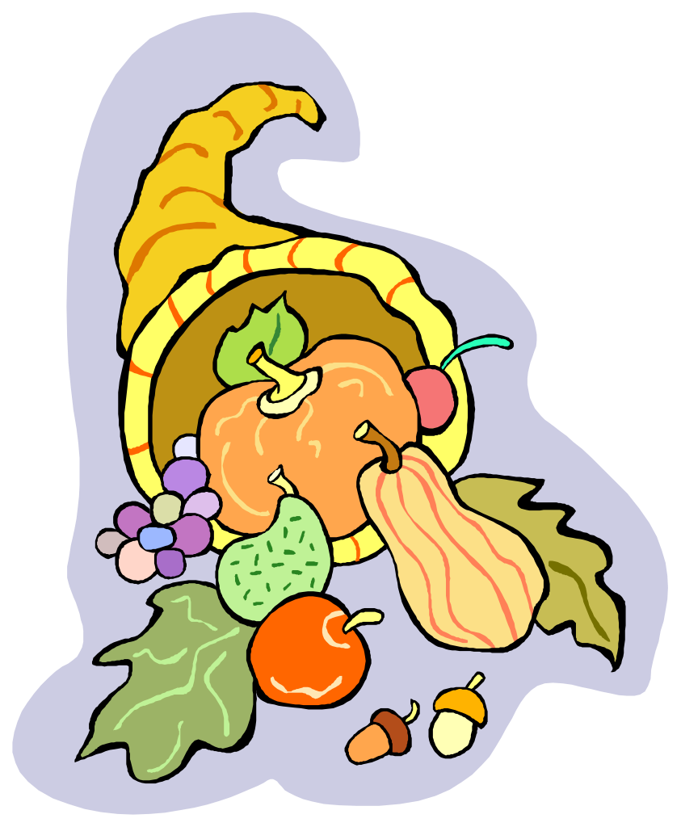
Social Service Association of Ridgewood & Vicinity
Thanksgiving Food Drive Suggestions
THANKSGIVING ITEMS - Boxed Mashed Potatoes, Chicken Broth and Gravy, Cranberry Sauce, Pumpkin and Stuffing Mix

PANTRY ITEMS:

Canned Tuna/Chicken/Ham/Spam
Canned or Plastic Bottled or Boxed 100% Fruit Juice
Peanut Butter and Jams/Jelly (no glass jars)
Canned Tomato Products (no glass jars)
(Spaghetti Sauce, Diced, Stewed, Puree, etc.)

Rice, Macaroni and Cheese

Shelf Stable Milk (Parmalat)

Cold and Hot Cereal (Oatmeal)

Pancake Mix & Syrup

Coffee & Tea
Snacks, Cookies & Crackers, Cake Mix

Mayonnaise, Mustard, Ketchup

Cooking Oil

Personal care items - toothpaste/soap/feminine products

Household cleaning products and paper products

***GROCERY GIFT CARDS ARE ALWAYS WELCOME SO WE CAN PURCHASE ITEMS WHEN WE ARE LOW IN THE PANTRY!!*****

